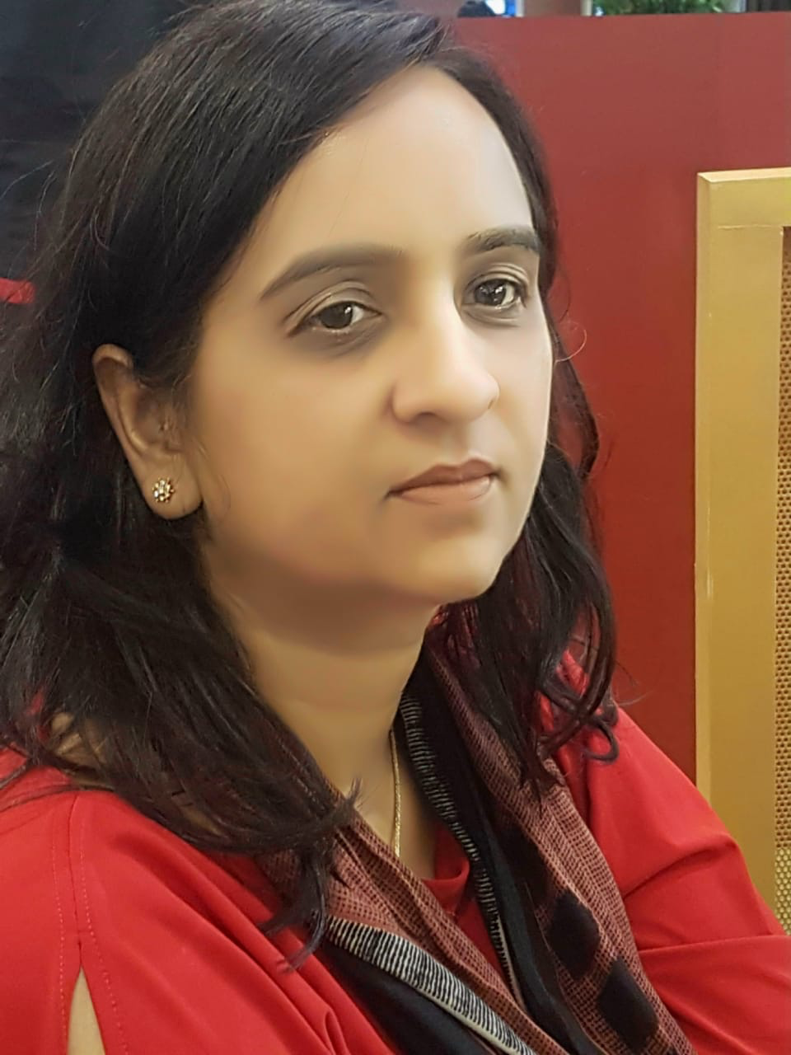
Dr.Garima Singh
Email:
drgarimasingh@ymail.com

Dr.Garima Singh ,Asst. Prof., Department of Mathematics, UIT,BU,has been the topper of Miranda House College, Delhi University in Mathematics(Hons.) & Receipient Of “USHA THIAGRAJAN MEMORIAL PRIZE” M.H.,Delhi University, Delhi.She did graduation and post graduation both from Delhi University, Delhi, thereafter did Ph.D. Mathematics from Barkatullah University Bhopal.
Her fields of specialization include Graph Theory ,Mathematical Modeling , Block Designs .She has teaching and research experience of more than 12 years.Under her supervision one MPCST Sponsored project has been completed.
Her many research papers have been published & has attended many international and national Conferences/Seminars /Workshops. 23 M.Phil. Degrees have been awarded under her supervision. She has been twice Barkatullah University Coordinator for Ph.D./M.Phil.Mathematics & Ph.D.Applied Mathematics Coursework and HoD (Mathematics) UIT, BU.
Apart from above she has Life Membership Of Many Prestigious Societies Like-Indian Science Congress Etc. Dr.Singh has organized many Conferences/Seminars.

