FAI Goa Chapter
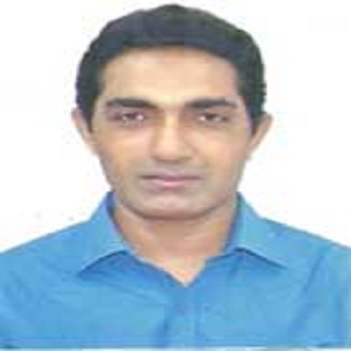
Mr.Roy Gomes
Secretary –FAI Goa Chapter Council
Associate Professor
Department Of Economics
Fr.Agnael College ,Pilar,Goa

